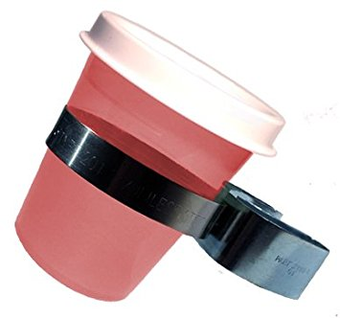
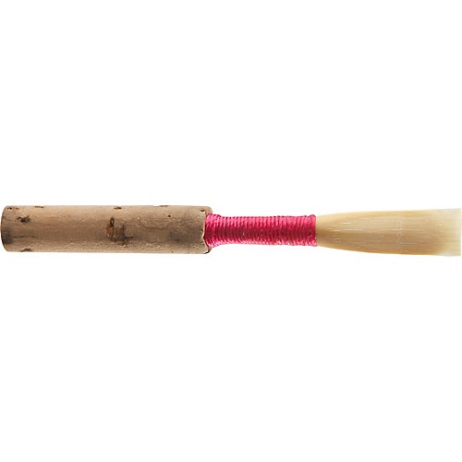
HELPFUL OBOE HINTS!

- HANDLE YOUR REEDS AND OBOE VERY CAREFULLY! OBOE KEYS BEND EASILY AND REEDS BREAK EVEN EASIER!

- Soak your reeds in tepid water (room temperature)! Do NOT use your mouth! Saliva is intended to break down stuff…… including the cane! Use fresh water as well. (Can you say bacteria?)

- Keep your reeds in a box that allows them to dry!

- ALWAYS, ALWAYS keep the key side of the oboe UP! This keeps water from making a track down the tone holes. (Gurgle….glort.)

- Never put anything on top of your oboe in the case! (Music, etc…)

- Use cork grease so the joints go on and off smoothly and try to protect the keys from getting bent!

- USE A SWAB- preferably with strings on BOTH ends. Swab the joints SLOWLY and start from the bell. (If the swab gets stuck, DON'T PULL!)

- NEVER leave or store your oboe near a window, radiator, damp basement, or hot attic (oboes are needy). *NEVER….EVER….LEAVE YOUR OBOE IN THE CAR! (Especially on cold or hot days!)

- Never use silver polish. Feel free to dust around the oboe keys with a little brush.

- Wash your hands and rinse your mouth (or brush your teeth) before you play.

- Always put your oboe away!

- Try not to leave your instrument on your chair in crowded rehearsals! (Hit...knock…crash!)

- If there is spit stuck in your keys, use cigarette paper (found in most music stores and the websites I have included in the this packet). If you don’t have cigarette paper, a dollar is a good temporary fix.

- Always have at least 3 good reeds in your case at all times!

