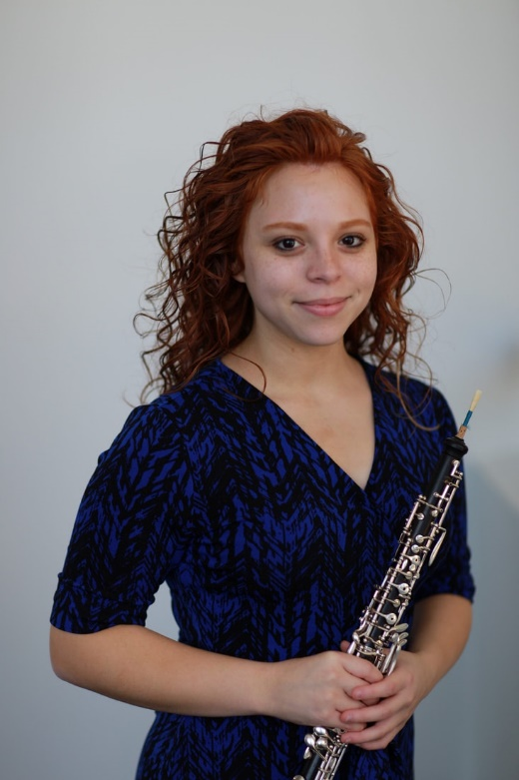

Originally from San Juan, Puerto Rico, Ms. Samantha Charriez began her teaching career as a band director at the brand-new Brambleton Middle School beginning the 2017-2018 school year. Bands under her direction have received consistent Superior ratings in assessment, and enrollment has increased in the program every year. There are now 500 students in the band program!
Ms. Charriez has a Bachelor's Degree in Music Education from George Mason University. During her studies at Mason, she was the principal oboist and section leader of the George Mason University Symphony Orchestra, Mason's Wind Symphony, and Symphonic Band. She began her Master’s Degree in Music Education last summer at the Vandercook College of Music. As an oboist, she is an active performer and teacher in the northern Virginia area and she has her own private oboe studio.
During the summer, she is a premier instructor at the Bocal Majority and Operation O.B.O.E. Camp, Judith Lapple Summer Woodwind Camp, and Rappahannock Summer Music Camp. She also served an administrative role at the Stafford Arts Summer Camp. In 2015, she was accepted to become a Potomac Arts Academy Teaching Scholar where she worked at Potomac Middle School and led after-school programs. In addition, she was selected to become an International Teaching Scholar where she traveled to Costa Rica to teach and perform at the music conservatory, SINEM schools, magnet art schools, and with the National Band of San José.
Ms. Charriez was given the honor to guest conduct this past year at VBODA’s District V Middle School All-District Band. In 2022, she is scheduled to guest conduct at VBODA’s District II All-District Band. She is an active member of NAfME, VMEA, the National Band Association, and the Women Band Directors International Association.
​When she is not doing something related to music, she loves to bake and spend time with her family and dogs.

